Project Documentation

AI BLOGNEST API

Project Title
ContentGen - Generate high-quality blog content usingAI
Team Members :
Divyadharshini .H
Janani .M
Abinaya .R
Aishwarya .B
Akshaya .A

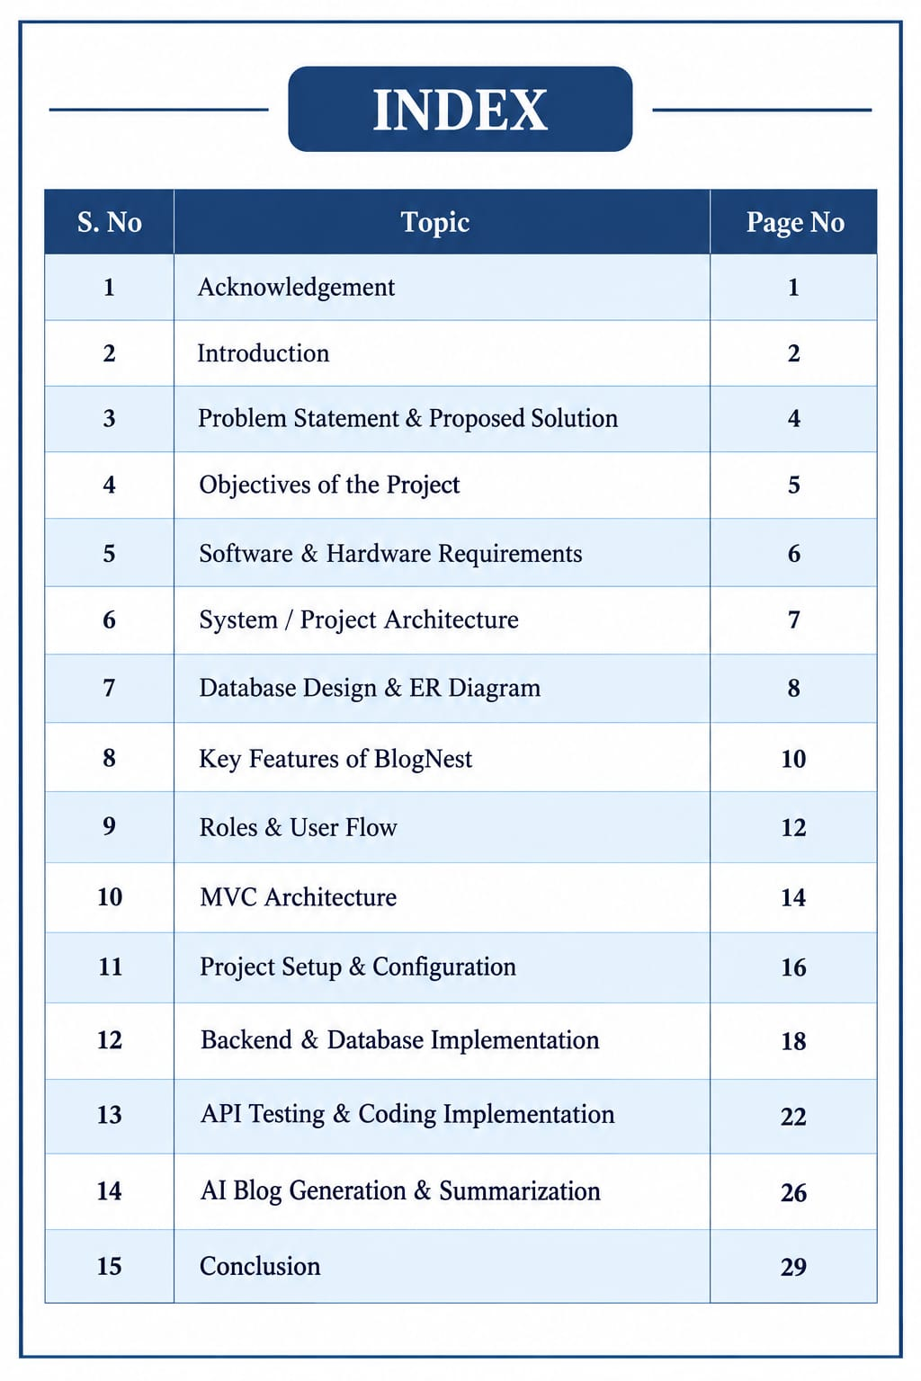

1. ACKNOWLEDGEMENT

I would like to express my sincere gratitude to everyone who supported me in completing the project titled “AI BlogNest API.”

First, I thank my institution and department for providing me with the opportunity to work on this project and improve my technical knowledge. I am grateful to my project guide and faculty members for their valuable guidance, suggestions, and continuous support throughout the development of the project.

I also thank my friends and classmates for their support and useful suggestions during the implementation and testing stages.

Finally, I would like to thank everyone who directly or indirectly contributed to the successful completion of this project.

2. INTRODUCTION

AI Blog Nest API is a modern backend application designed to simplify blog creation, management, and AI-assisted content generation.

The system is developed as a RESTful API using Node.js and Express.js. MongoDB is used for storing application data, while Mongoose provides an organized way to create schemas and communicate with the database.

The major purpose of AI Blog Nest API is to provide a centralized backend that can handle users, blog posts, categories, comments, media information, and content-related operations.

The project also integrates Google Gemini AI to provide intelligent features such as AI-powered blog generation and blog summarization. This allows users to create structured content from simple topic-based inputs and u

The system follows a modular architecture so that different functionalities can be maintained separately. Authentication, authorization, database operations, business logic, API routes, and AI services are organized into different layer

3. PROBLEM STATEMENT AND PROPOSED SOLUTION
Problem Statement
Managing a blog platform manually can become difficult when the number of users and posts increases.

Some common problems are:
- Managing multiple blog drafts.
- Organizing posts using categories and tags.
- Controlling different types of users.
- Managing comments and moderation.
- Searching and retrieving blog content.
- Maintaining secure user information.
- Generating content quickly.
- Summarizing lengthy blog content.
- Managing media-related information.
- Tracking content-related activities.
The uploaded case study describes a content creator who faces difficulties in organizing drafts, categories, tags, publication processes, comments, media information, and user permissions.

Proposed Solution :
AI BlogNest API provides a centralized backend solution for these problems.

The system provides:
- User authentication.
- Role-based authorization.
- Blog CRUD operations.
- Category and tag management.
- Comment management.
- API-based content access.
- AI blog generation.
- AI summarization.
- Database validation.
- Secure password storage.
- Protected API endpoints.

The backend separates business logic from frontend applications, allowing different frontend clients to communicate with the same API.

4. OBJECTIVES OF THE PROJECT

The main objectives of AI BlogNest API are:

1. To develop a centralized backend for blog management.
2. To provide RESTful API endpoints for application operations.
3. To securely manage user accounts.
4. To implement role-based access control.
5. To store blog information efficiently using MongoDB.
6. To provide complete blog CRUD functionality.
7. To manage comments and moderation.
8. To support categories and tags.
9. To integrate AI-based blog generation.
10. To provide automatic blog summarization.
11. To validate and sanitize user inputs.
12. To provide secure and maintainable backend architecture.
13. To simplify API testing using Postman or similar tools.
14. To create a scalable structure for future development.

5. SOFTWARE AND HARDWARE REQUIREMENTS
Software Requirements:
Software| Purpose
Windows / macOS / Linux| Operating System
Node.js| Backend runtime
npm| Package management
Express.js| Backend web framework
MongoDB| Database
Mongoose| Database ODM
Visual Studio Code| Code development
Postman / Thunder Client| API testing
Google Gemini AI| AI content generation and summarization
The original project document specifies Node.js, npm, Express.js, MongoDB, Postman and a code editor as the major software requirements.

Hardware Requirements:
- Processor: Intel Core i5 / AMD Ryzen 5 or equivalent.
- RAM: Minimum 8 GB.
- Recommended RAM: 16 GB for smoother concurrent execution.

6.PROJECT ARCHITECTURE
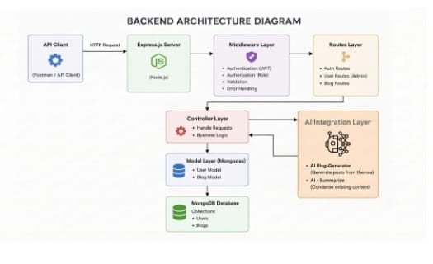

AI BlogNest API follows a layered backend architecture.

The basic request flow is:

Client → Express Server → Authentication → Controller → Service/Logic → Mongoose → MongoDB

For AI-related requests:

Client → API Route → Controller → AI Service → Gemini AI → Response

Major Components :

1. API Interface
API clients such as Postman can send HTTP requests to the backend.

2. Express Server
Express.js handles routes, HTTP methods, JSON requests, and server-side processing.

3. Authentication Middleware
JWT tokens are checked before accessing protected resources.

4. Authorization
The user's role is checked before allowing specific operations.

5. Controller Layer
Controllers receive requests, process required operations, and return responses.

6. Service Layer

Business rules and specialized operations are handled separately.

7. Database Layer

Mongoose communicates between the Node.js application and MongoDB.

8. AI Service

The AI service communicates with the external AI model for content generation and summarization.

The project document describes this layered architecture and specifically identifies the Express gateway, authentication/role middleware, logic modules, database interface, and AI flow.

7.DATABASE DESIGN AND ER DIAGRAM
MongoDB is used as the primary database of the project.

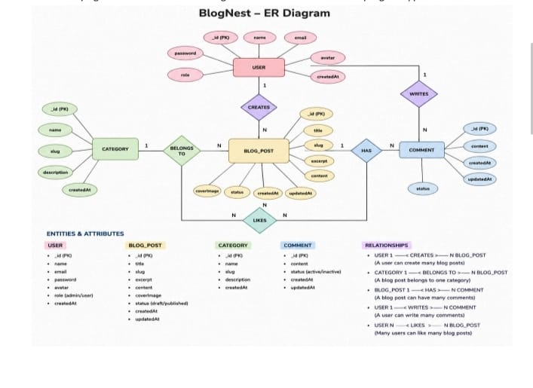

The main entities described in the project are:

User
Important fields include:
- "_id"
- "name"
- "email"
- "password"
- "role"
The password is stored in hashed form.

Post
Important fields include:
- "_id"
- "userID"
- "name"
- "photo"
- "message"
- "likes"
- "timestamps"

Comment
Comments are associated with users and posts.

Relationships
User → Post
One user can create multiple posts.

Relationship: One-to-Many

User → Comment

One user can create multiple comments.

Relationship: One-to-Many

Post → Comment

One post can contain multiple comments.

Relationship: One-to-Many
The document specifies these relationships and the principal User and Post fields.

8. KEY FEATURES OF AI BLOGNEST API

User Authentication
Users can register and log in through API endpoints.
Role-Based Access Control

The system supports different roles:
- Admin
- Editor
- Author
- Reader
Each role receives different permissions.

Blog CRUD
The system supports:
- Create blog
- Read blog
- Update blog
- Delete blog

Categories and Tags
Blogs can be organized using categories and tags to improve content discovery.

Comment Management
Comments can be handled through protected API endpoints.

Search
Search functionality helps users locate relevant content.

AI Blog Generation
The AI service generates structured blog content based on a given topic or input.

AI Summarization
Long content can be converted into a shorter summary.

Security
The system includes authentication, password hashing, validation, sanitization, rate limiting, and structured logging

8.ROLES AND USER FLOW

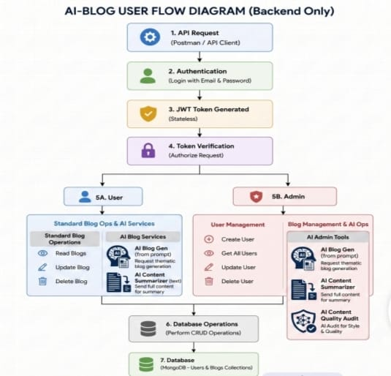

Admin
The Admin has the highest level of access.

Responsibilities include:
- Managing users.
- Changing user roles.
- Managing system-level settings.
- Moderating problematic comments.
- Viewing system information.

Editor
The Editor mainly handles content workflows.

Responsibilities include:
- Reviewing posts.
- Managing publishing status.
- Managing categories.
- Reviewing pending content.

Author
The Author creates and manages their own blog content.

Reader
The Reader primarily consumes published content and can participate through comments.

The role definitions in the source document distinguish Admin, Editor, Author, and Reader permissions.

User Flow

Register → Login → Receive Token → Access API → Perform Authorized Operation → Database → Response

9.MVC ARCHITECTURE
The project follows the Model-View-Controller (MVC) pattern.
Model
The Model defines the database structure.
Mongoose schemas specify fields, validation rules, default values, and database-related properties.

Controller
The Controller processes incoming requests.
1. Receives the request.
2. Validates required information.
3. Calls appropriate business logic.
4. Communicates with the model.
5. Returns the response.
View
Since AI BlogNest API is a headless backend, it does not use traditional HTML template views.
The API routing layer acts as the interface between external clients and controller logic.
The source document explicitly describes Model, Controller, and API Routing layers in its MVC implementation.

10. PROJECT SETUP AND CONFIGURATION

Project Folder
A separate project folder is created for AI BlogNest API.
A server-side folder is used to contain backend files.

Example structure:
AI-BlogNest-API/
│
├── Server/
│ ├── server.js
│ ├── app.js
│ │
│ ├── models/
│ ├── controllers/
│ ├── routes/
│ ├── middleware/
│ └── services/
│
└── package.json

NPM Initialization
The Node.js project is initialized using:
The project document also identifies "server.js", "models", "controllers", and "routes" as part of the initial backend setup.

CONFIGURATION :

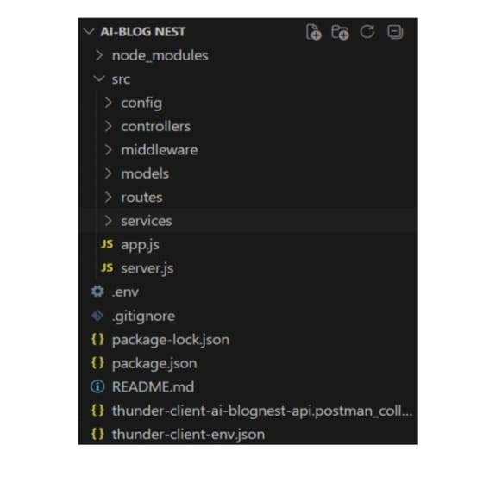

11. BACKEND AND DATABASE IMPLEMENTATION

Backend Server
The backend is developed using Node.js and Express.js.

The server is responsible for:

- Starting the application.
- Handling API requests.
- Connecting middleware.
- Connecting routes.
- Managing responses.
- Handling errors.

Database Connection
MongoDB is connected through Mongoose.

The basic process is:
Node.js Application → Mongoose → MongoDB

The project uses Mongoose for schema definitions and database communication.

Schema
Schemas define how information is structured before being stored in MongoDB.

Example User schema fields:
name
email
password
role

Backend Development(CODE):
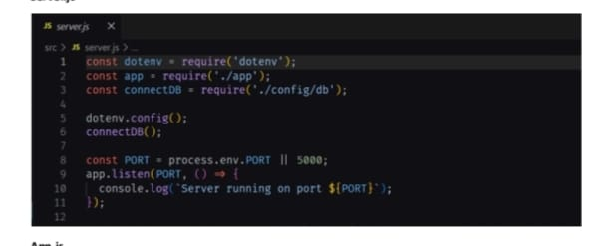

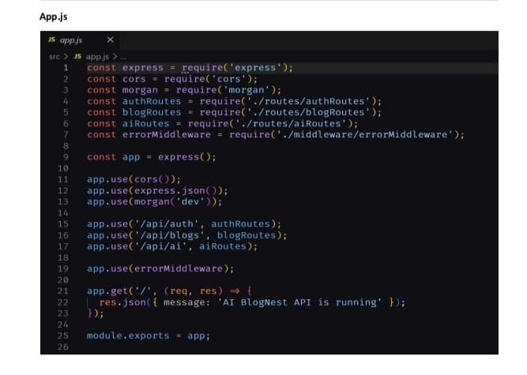

12. API TESTING AND CODING IMPLEMENTATION
API testing is performed using Postman or Thunder Client.

The backend server can be started using:
npm start

API testing verifies whether each endpoint is working correctly and whether the expected request and response structures are produced.

Important API Testing Screenshots
User Registration
Test the registration endpoint with user information.

User Login
Verify login credentials and authentication response.

Create Blog
Send blog information through the API.

Fetch Blogs
Retrieve available blog records.

Update Blog

Modify existing blog information.

Delete Blog

Remove an authorized blog record.

USER REGISTRATION POSTMAN/ LOGIN POSTMAN:

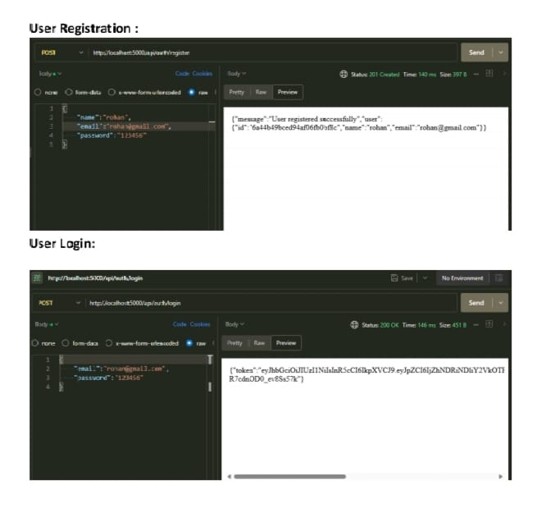

CREATE BLOG CODE/ FETCH BLOGS POSTMAN:

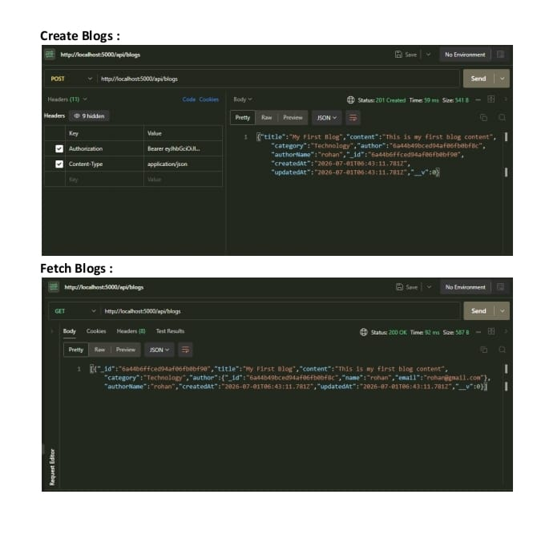

13. AI BLOG GENERATION AND SUMMARIZATION

One of the major features of AI BlogNest API is AI-assisted content processing.
AI Blog Generation
The user provides a topic or high-level idea.
The system sends the input to the AI service.
The AI service processes the request and generates structured blog content.
Process
Topic → API Request → Controller → AI Service → Gemini AI → Generated Blog → API Response
The project document identifies AI blog generation through a dedicated AI flow and "/api/ai/generate-blog" endpoint.

AI Blog Summarization
The summarization feature processes longer blog content and generates a concise version.
Process
Long Blog → API Request → AI Service → Summarization → Short Summary → Response

The source document identifies "/api/ai/summarize" as the summarization endpoint.

SUMMARIZATION CODE/ SUMMARY OUTPUT:

